**Table: STORE**

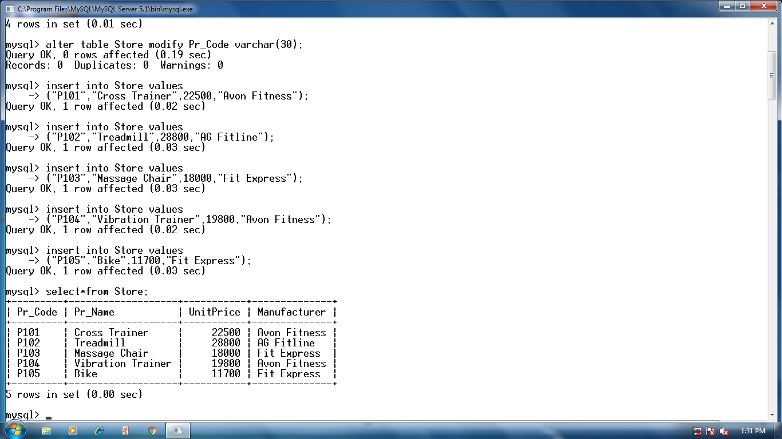

**QUERIES:**

1. Display the names of all the products in the store.

2. Display the names and unit price of all the products in the store.

3. Display the names of all the products with the unit price less than 21000.

4. Display details of all the products with unit price in the range 25000 to 40000.

5. Display the names of all the products by the manufacturer “Fit Express”.

6. Display all rows in ascending order by product name.

7. Change the unit price of all the rows giving 10% discount.

8. Display records with the manufacturer starting with ‘A’.

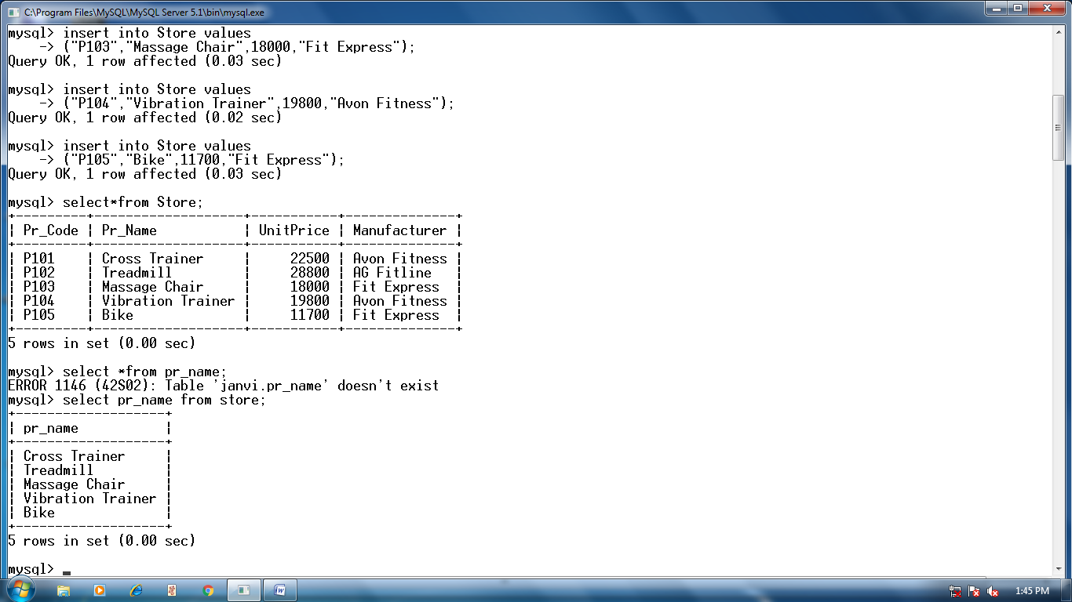

**2.**

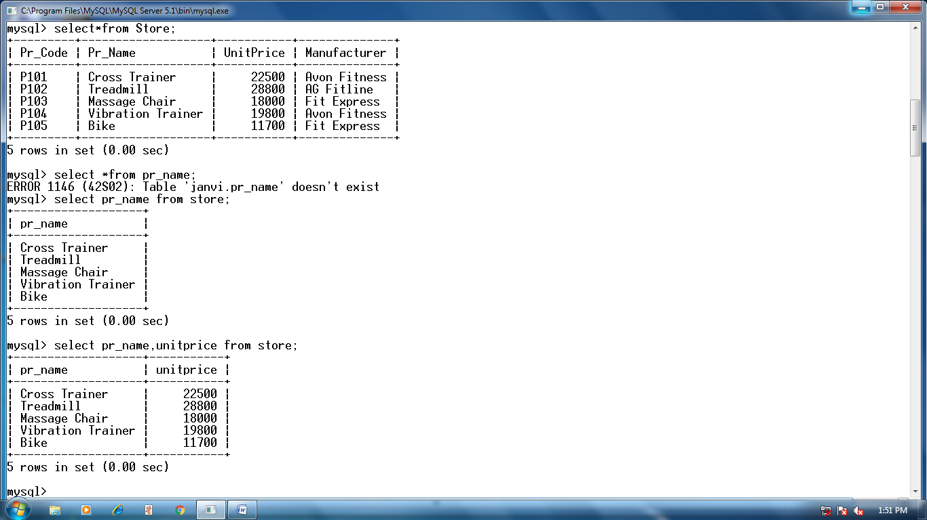

**3.**

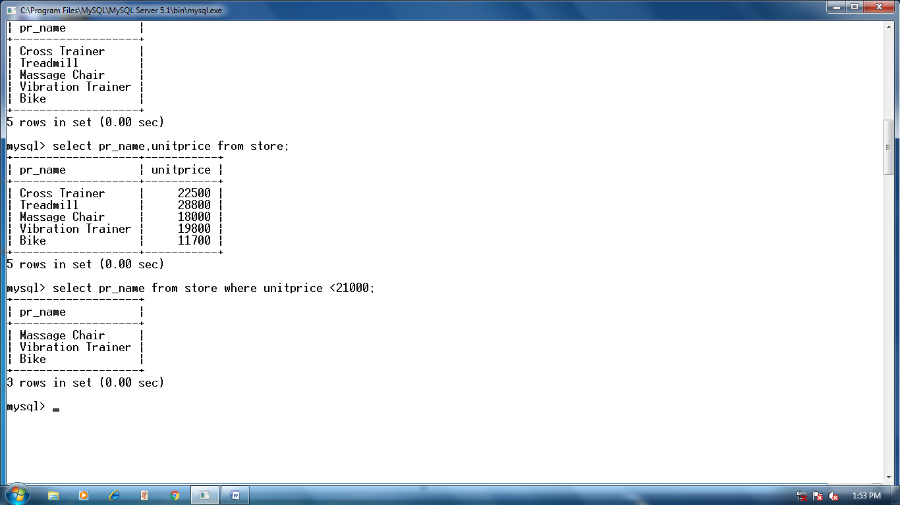

**4.**

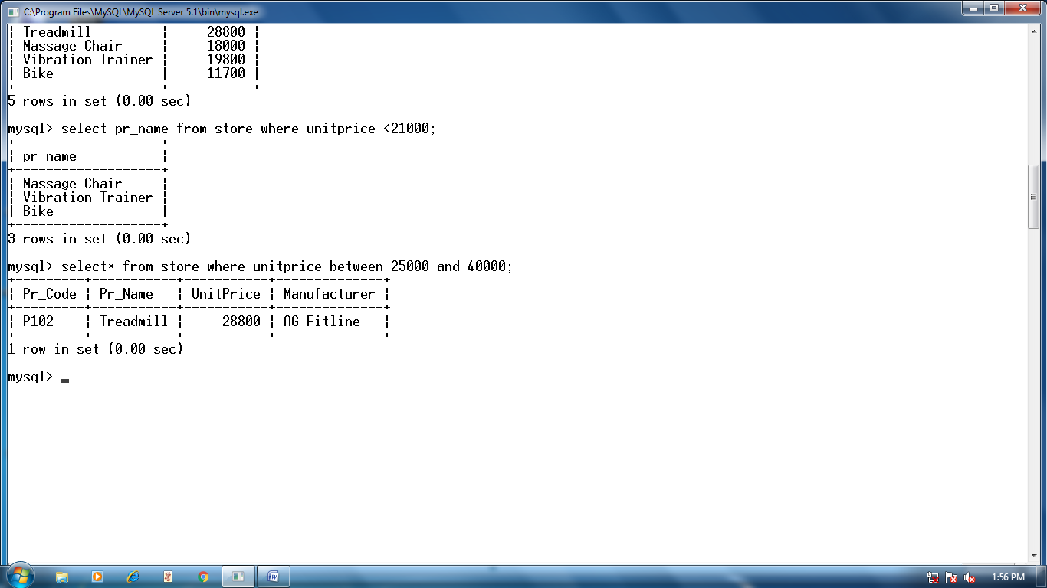

**5.**

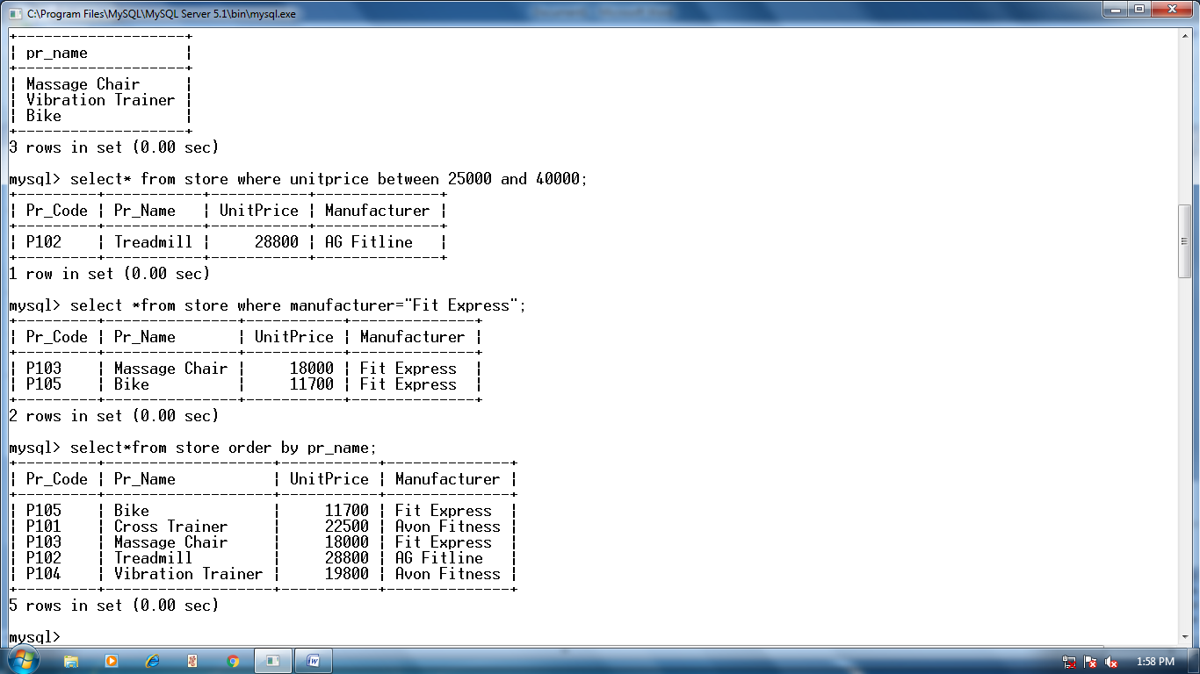

**6.**



**7.**

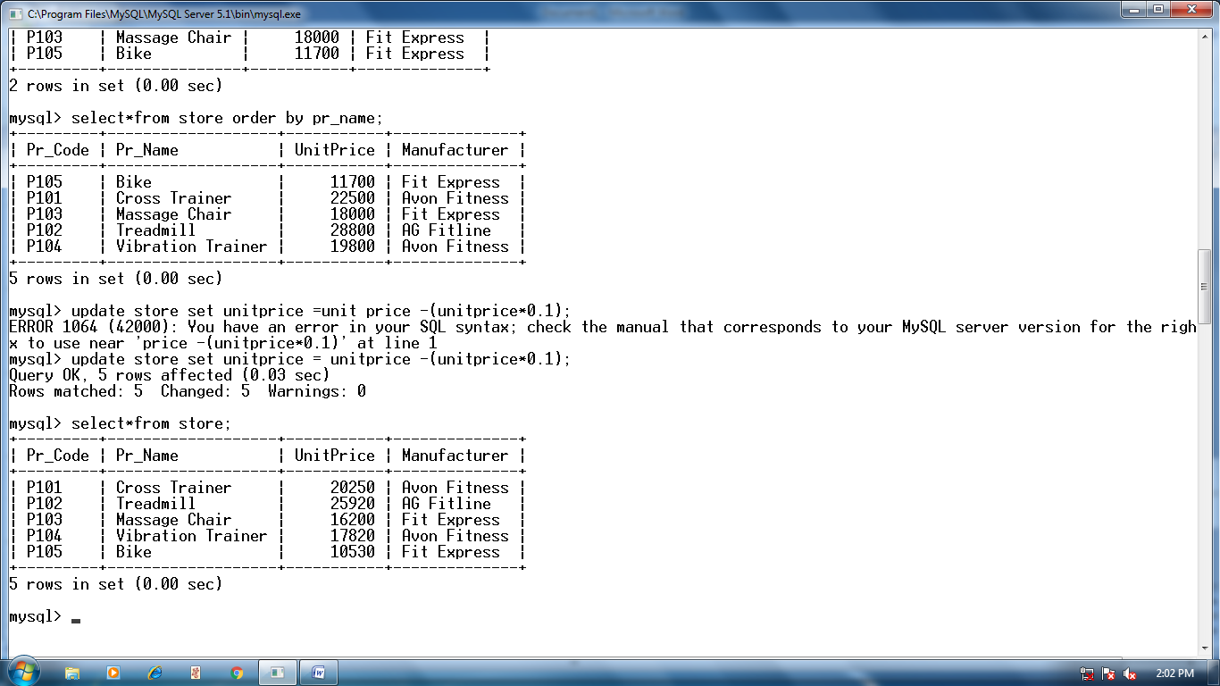

**8.**

